======================================================================
Name:- Nitin Kumar
Roll No:- 2025AG05921
Subject- DM4ML Assignment 2 (End-to-End Data Management Pipeline for e-commerce)
Dataset: abhayayare/e-commerce-dataset(https://www.kaggle.com/datasets/abhayayare/e-commerce-dataset)
======================================================================
✅ Screen shot of Successful Run
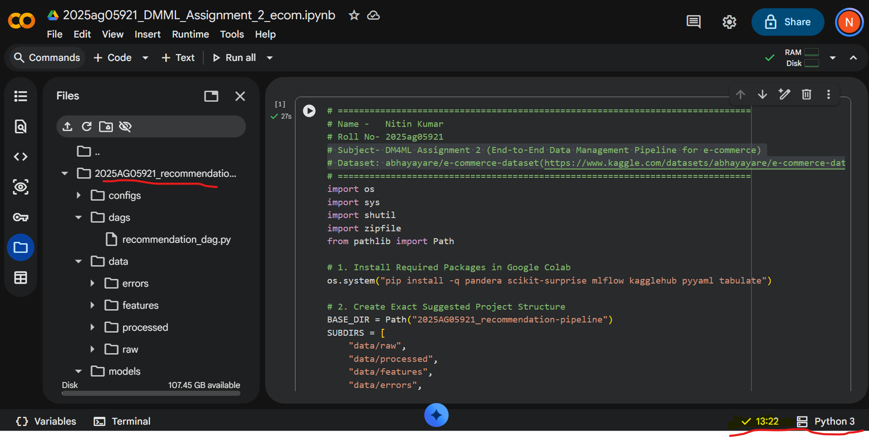
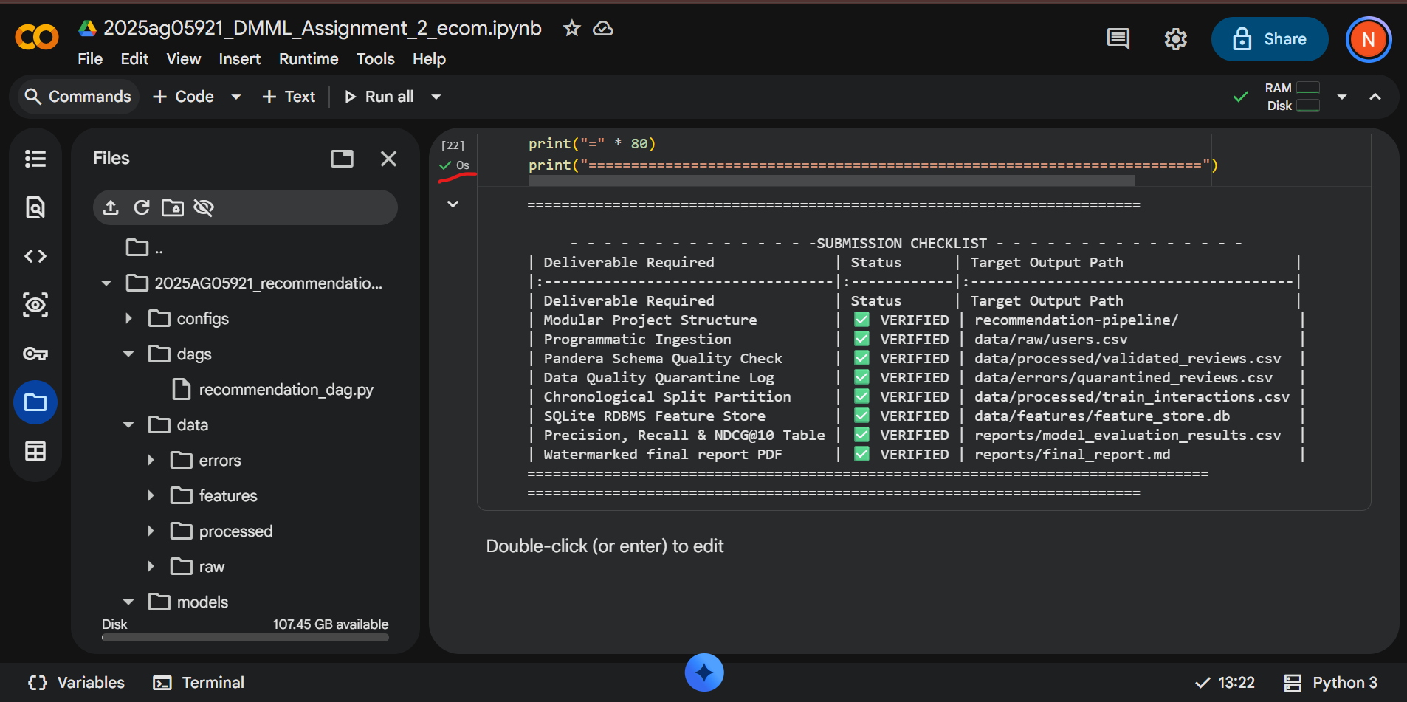

✅Project Structure
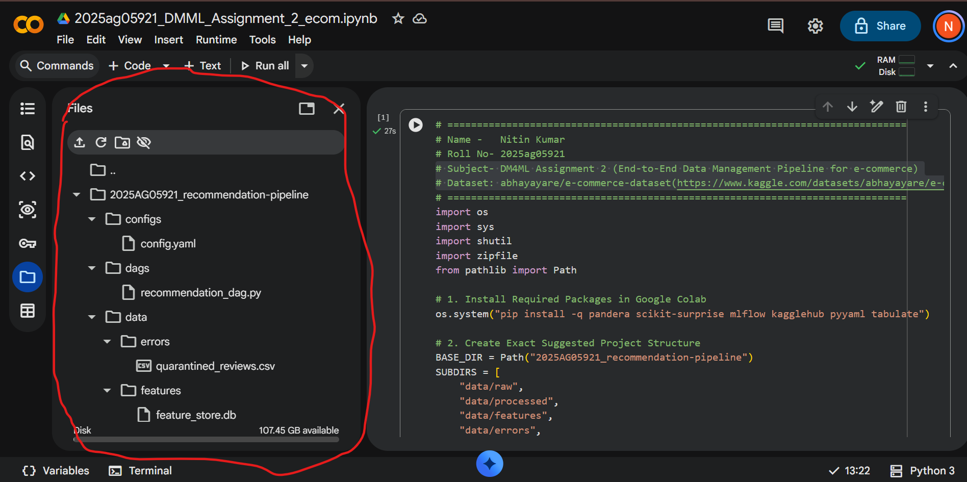
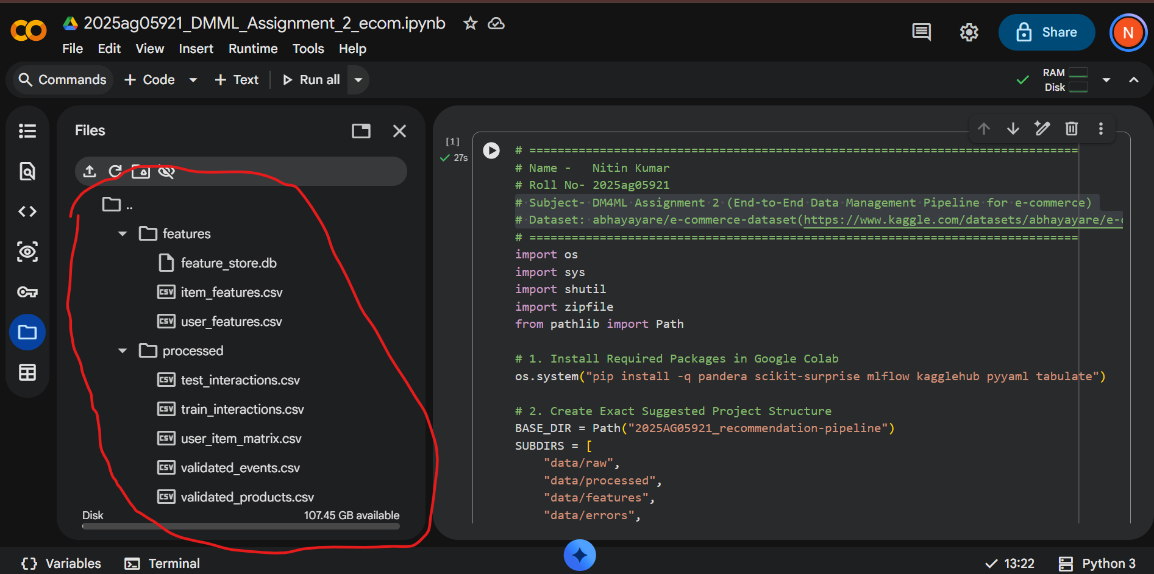
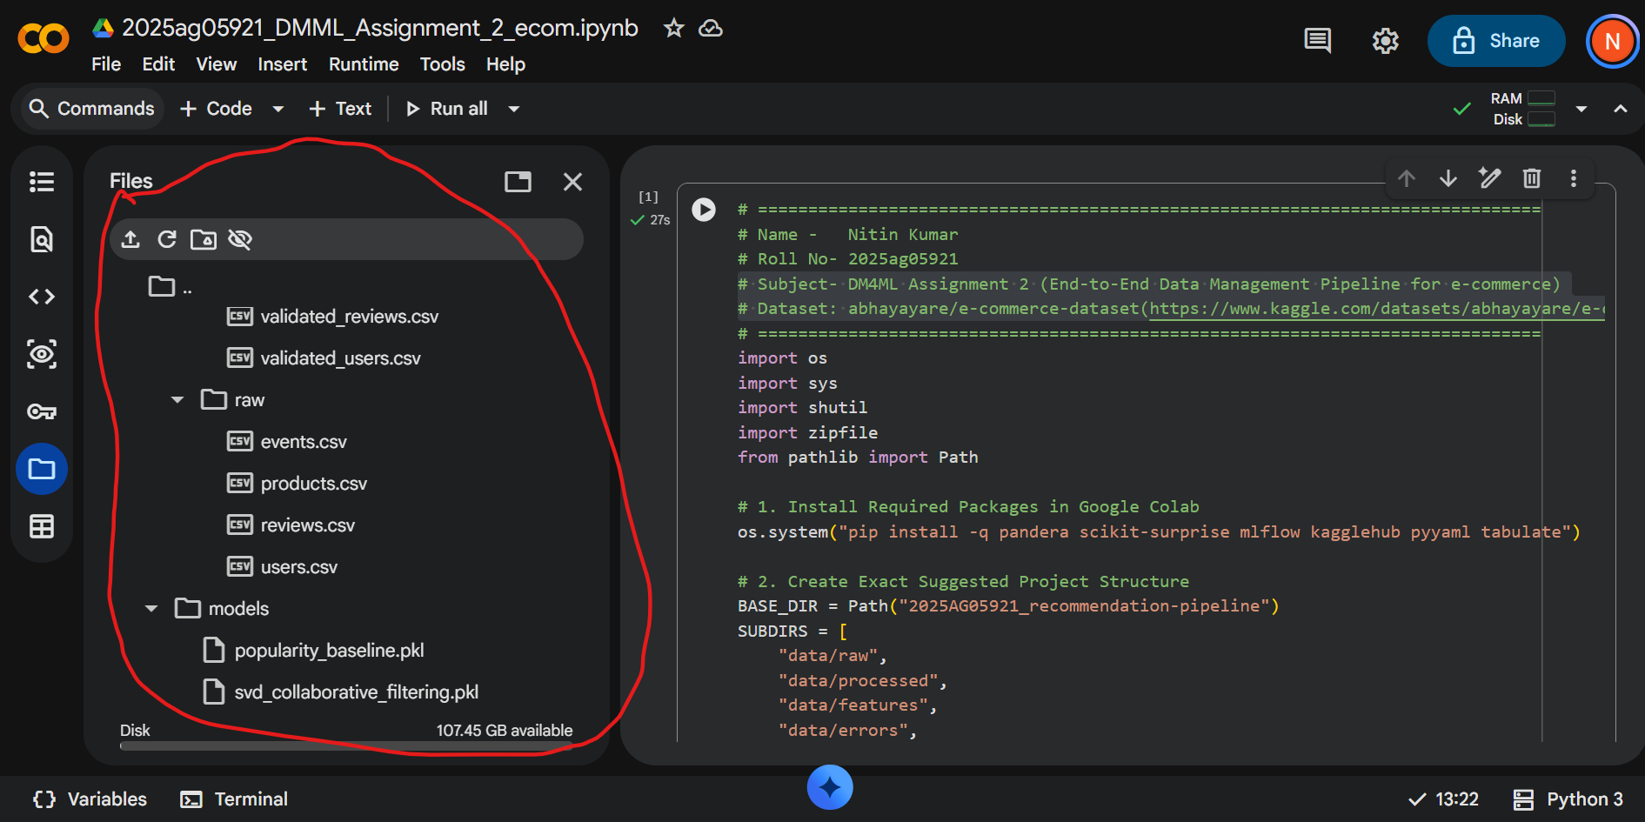
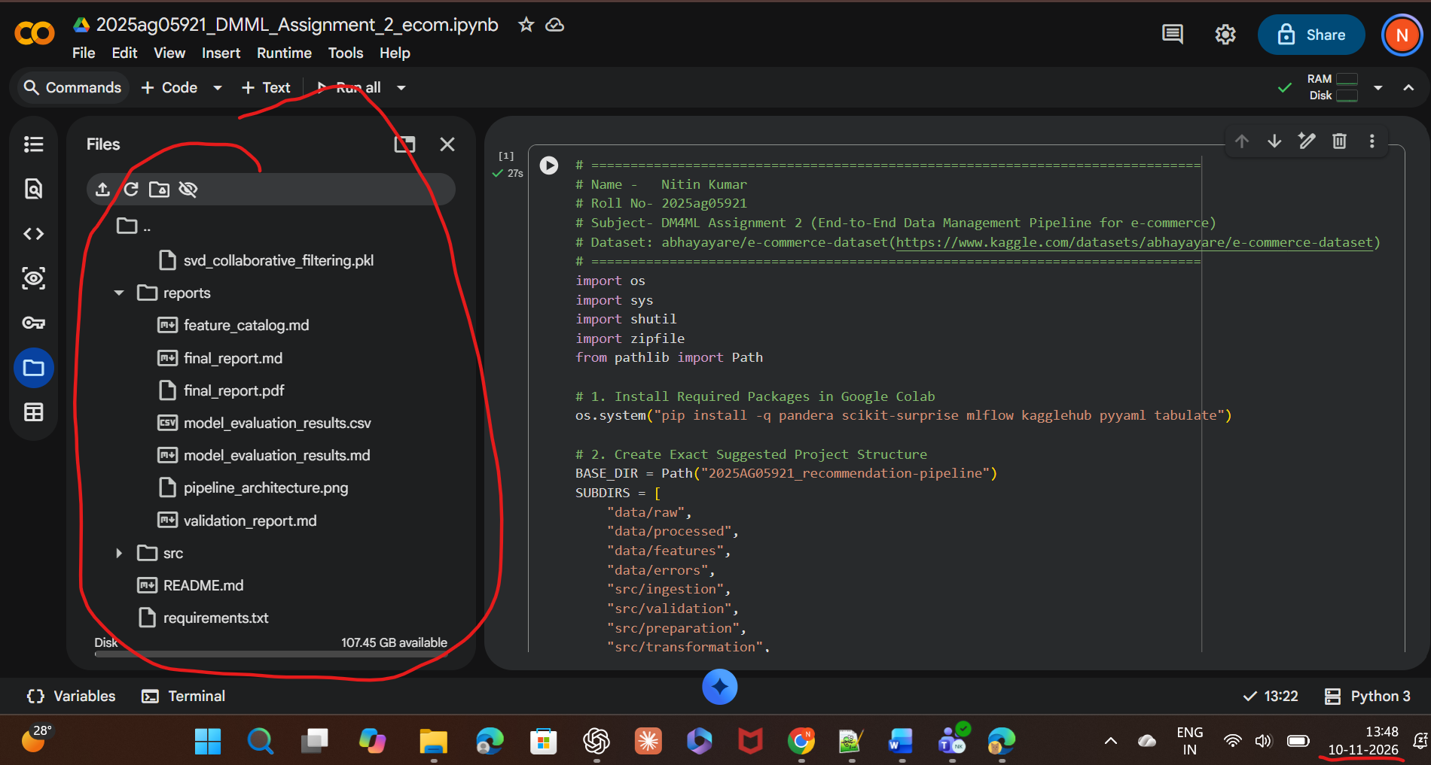

✅ DAG RUN SUCCEEDED IN 3.20s | Roll No: 2025ag05921


